**Floods in India** are turning more severe, unpredictable and rather intractable. Number of urban floods is on the rise mainly due to poor drainage and encroachment of old water bodies of cities and towns.

Unmanned Aerial Vehicles (UAVs) or drones are often used to reach remote areas or regions which are inaccessible to humans. Equipped with a large field of view, compact size, and remote control abilities, drones are deemed suitable for monitoring crowded or disaster-hit areas, and performing aerial surveillance. While research has focused on area monitoring, object detection and tracking, limited attention has been given to person identification, especially face recognition, using drones.

To the best of our knowledge, limited attention has been given to the challenging yet important application of drone based face recognition. Automating the process of face recognition or tracking using drones can greatly benefit surveillance and remote monitoring scenarios

Drone based face recognition brings with it a new set of challenges such as the effect of motion, pose, illumination, background, and height. The presence of these challenges, along with the relatively lower resolution of captured faces, varying distance between the drone and the subjects, the problem of drone based face recognition is thus rendered further challenging.

USE OF FACE DETECTION 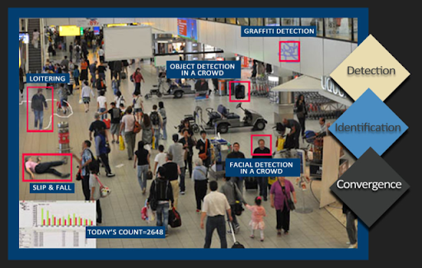

*Use of face detection technique post floods:*

* Face detection datasets recognise tasks such as progression/regression, landmark localization, etc[. https://susanqq.github.io/UTKFace/](. https:/susanqq.github.io/UTKFace/)
* After the flood crisis there will be devastating loss for human mankind. During the floods most of the people will be drowned, died, injured. Also sometimes it so happens that injured people will be rescued by the rescuers , but it becomes difficult to identify their faces due to facial injury, etc.

In order to detect the faces , high end face detection technique can be used .Wherein aerial view of their face will be taken and it will be stored in database. There training and testing of datasets takes place using machine learning or deep learning. Data will be trained based on the previous input images.

* Then the relatives/friends of particular person leaving in safe zone around flooded area can soon pick up him/her from the flooded place and can shift them to their place if the situation after the flood is too worst.
* Drone face detection technique can also be used to find out the missing person drowned in flood. Drones can be used for more precision to find out the people struck under building debris, etc.
* In this way more loss of lives can be prevented.

Improving Transport facilities post floods:

Positive trends, however, are visible. Economic development, technological progress and targeted adaptation interventions help reduce flood impacts over time.

An increasing number of catastrophic weather-related events across the globe have seen the safety and resilience of infrastructure networks become an important issue in recent years. A resilient transport system is considered to have the ability ‘to withstand the impacts of extreme weather, to operate in the face of such weather and to recover promptly from its effects The focus of this paper is on the impacts and operation during extreme weather, rather than recovery. To improve the ability to avoid or limit the effects of hazard events (such as flooding) where possible, it is essential that a greater level of understanding of the behaviour of networks under hazard conditions is developed, alongside improved modelling methodologies and techniques which can allow the assessment of options for reducing the impact of hazards .

Adaptation can involve moving infrastructure away from flood-prone areas (i.e. diverting roads), improving the resilience of existing infrastructure *in situ* (i.e. improving drainage along roads, raising roads where flooding is expected to occur), or use of permeable paving. An increasingly important option for increasing urban resilience to flooding are sustainable urban drainage systems (SUDS). SUDS pay particular attention to the source and pathway stages of the flood process , as opposed to traditional engineering solutions to stormwater management (e.g. drainage channels and sewerage systems). SUDS seek to use natural processes to reduce initial run-off through source interventions, such as blue or green surfaces (e.g. parks, ponds, roofs), and to increase the retention and infiltration of water . These adaptations intercept or reduce run-off before it reaches the receptors, thereby reducing the magnitude of the hazard at the infrastructure. Such measures are also often referred to as Blue Green Infrastructure (BGI). Other options include building redundancy into the network (i.e. providing alternative routes) or increasing mode share for more resilient transport modes (i.e. encouraging shift from private car-based transport to public transport, walking and cycling)

An integrated assessment framework that combines hazard modelling, graph theory and transport networks analysis is used to enable evaluation of the effectiveness of different adaptation strategies ([figure 1](https://royalsocietypublishing.org/doi/10.1098/rsos.160023#RSOS160023F1)). This work has used data and models that are appropriate to a UK application but, data permitting, the principles are transferable.

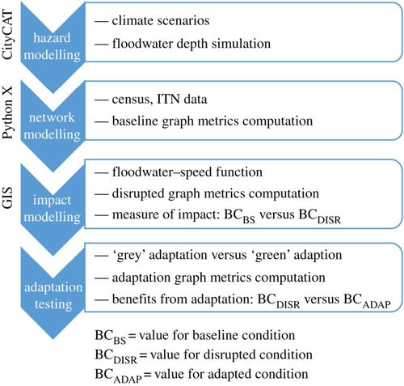

Figure 1. The integrated assessment framework for transport disruption analysis.

.